Installing Visual Studio for C++ coding is a straightforward process. Follow these step-by-step instructions to set up Visual Studio:

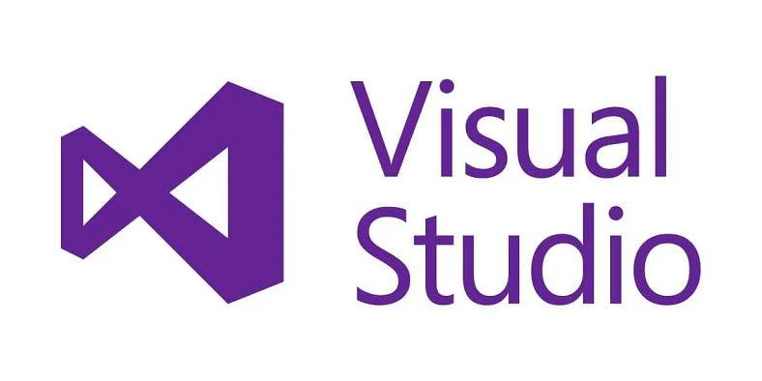

1. Download Visual Studio:  
> Visit the official Visual Studio download page: [Visual Studio Downloads](<https://visualstudio.microsoft.com/downloads/>)  
> Click on the “Download Visual Studio” button.

2. Select an Edition:  
> Visual Studio offers different editions, including Community (free), Professional, and Enterprise. For most individual developers and students, the Community edition is sufficient. Click on “Community” to download it.

3. Run the Installer:  
> Once the installer is downloaded, run the executable file (e.g., `vs_community.exe`).

4. Choose Workloads:  
> During the installation process, you’ll be prompted to choose workloads. For C++ development, select the “Desktop development with C++” workload. This workload includes the necessary tools and libraries for C++ development.

5. Select Individual Components (Optional):  
> If you have specific preferences or need additional components, click on the “Individual components” tab and select the desired components. Common options include “Git for Windows” and “GitHub Extension for Visual Studio.”

6. Modify Installation Path (Optional):  
> You can choose to modify the installation location by clicking on the “Installation locations” tab. By default, Visual Studio installs to the C drive.

7. Install:  
> After making your selections, click on the “Install” button to begin the installation process. This may take some time, depending on your internet connection speed and the selected components.

8. Sign In (Optional):  
> You may be prompted to sign in with a Microsoft account. Signing in is optional, but it allows you to synchronize your settings across different devices.

9. Complete Installation:  
> Once the installation is complete, you’ll see a screen indicating successful installation. Click on the “Launch” button to open Visual Studio.

10. First-Time Setup:  
> On the first launch, Visual Studio might prompt you to configure your development environment. You can choose the default settings or customize according to your preferences.

11. Install C++ Compiler (if needed):  
> Depending on your workload selection, Visual Studio may prompt you to install the necessary components for C++ development. Follow the on-screen instructions to install the required components.

12. Verify Installation:  
> Create a new C++ project or open an existing one to verify that the installation was successful. You can go to “File” > “New” > “Project” and select a C++ template.

Congratulations! You have successfully installed Visual Studio for C++ coding. Now, you can start creating and building your C++ projects using the powerful features provided by Visual Studio’s integrated development environment.